**NS-3**

**Packet size = 128 , Throughput = 69.333**

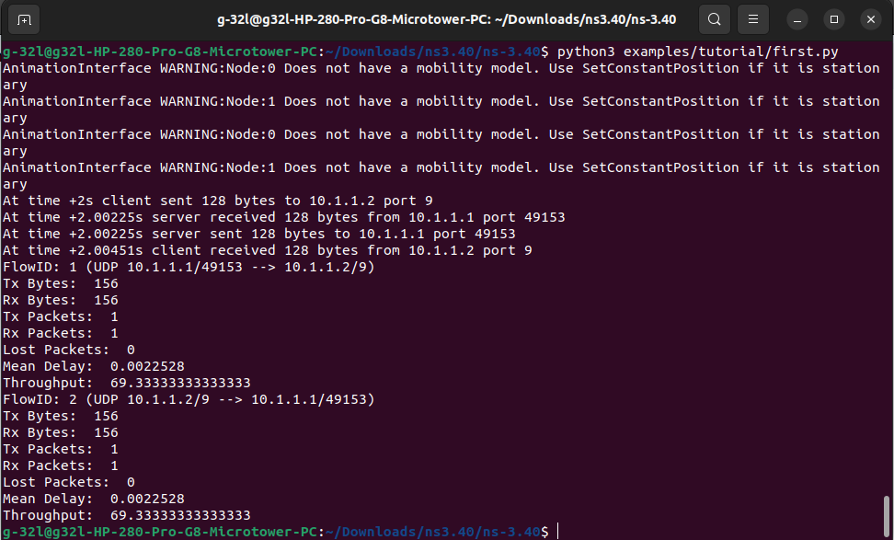

**Packet size = 256 , Throughput = 126.222**

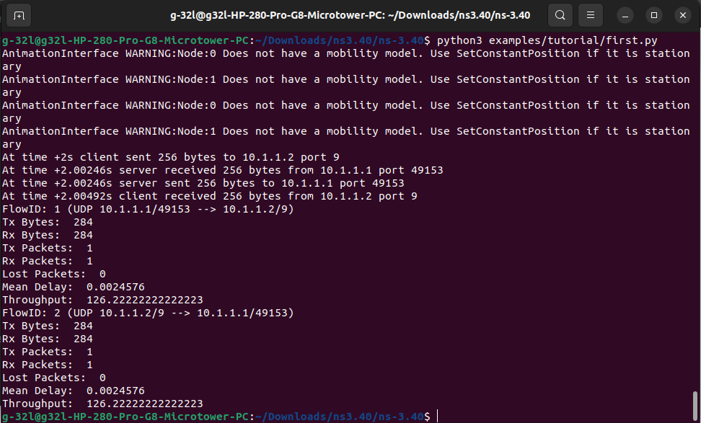

**Packet size = 512 , Throughput = 240.000**

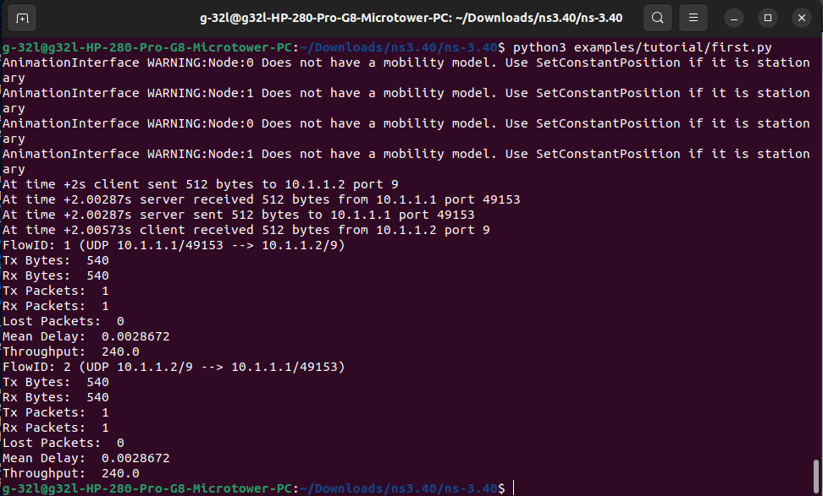

**Packet size = 1024 , Throughput = 467.555**

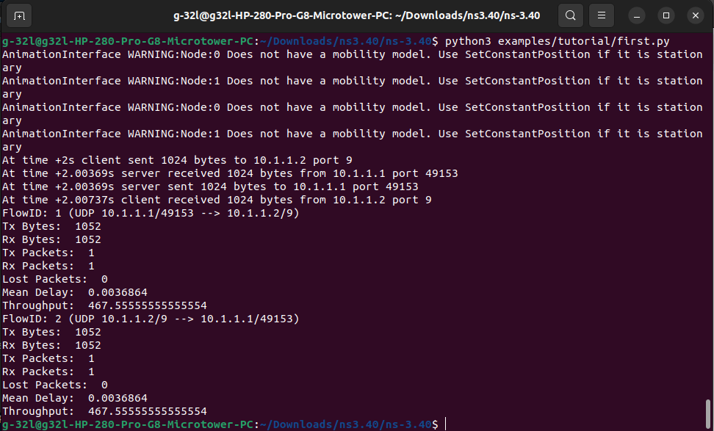

**Packet size = 2048 , Throughput = 992.666**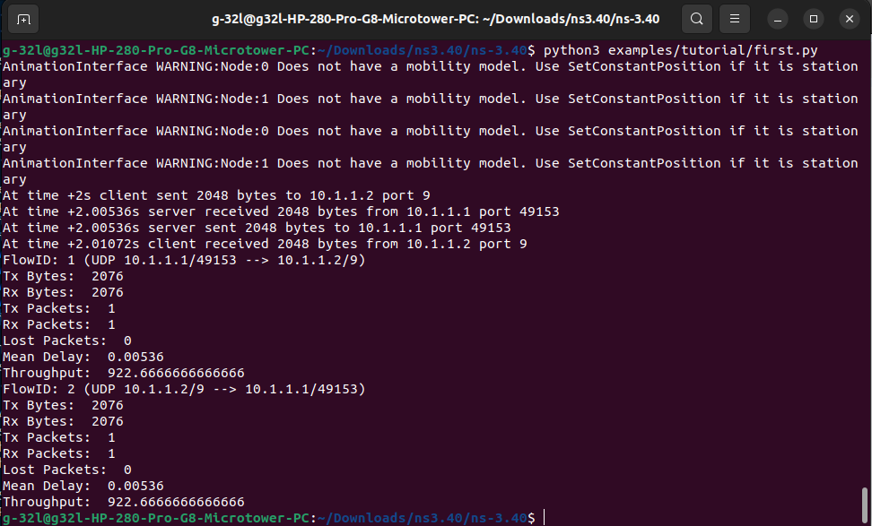

**Graph:**

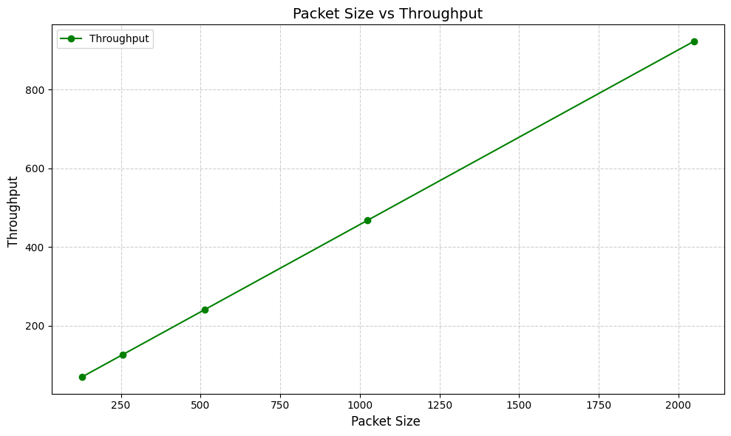

Throughput is positively correlated with packet size, as increasing the packet size results in a corresponding increase in throughput. Larger data packets utilize the data link's bandwidth more efficiently, reducing overhead and enabling faster data transmission compared to smaller packets.